**Students Projects**

**1. Name : Reshu Vishwakarma**

**CSE 7th Semester  
Batch (2012-16)**

**Website:**                      [Divas-World.azurewebsites.net](http://Divas-World.azurewebsites.net)

                                                (**Description**-

It consists of  Pageant’s life-story, achievements, photos, videos, final round questions asked to them in Miss Universe contest.

**Technology used**-  Visual Studio2013

                                                                L**anguage used**-     HTML and CSS)

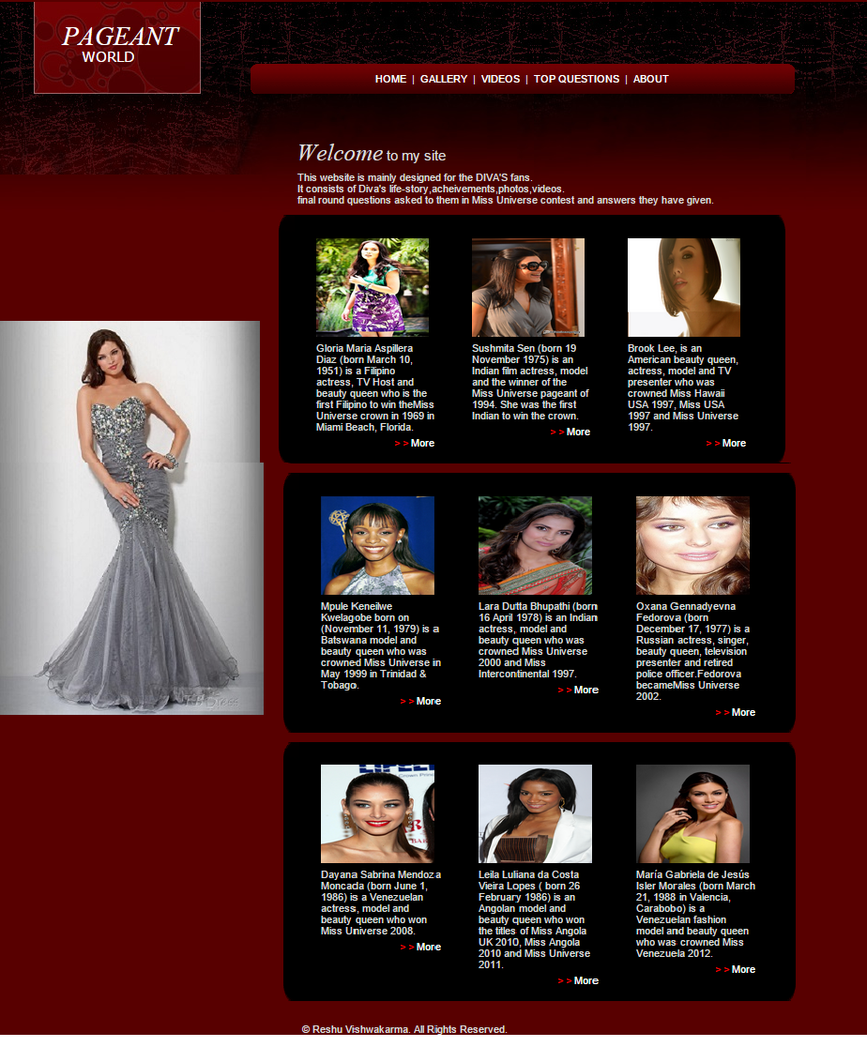

**Windows App:** How cricketers got their life-partners???

                                                (**Description**-

                                                                It is a static windows app which reveals the                                                                         real life story of many Indian cricketers.

**Link**-   <https://www.microsoft.com/en-us/store/apps/how-cricketers-got-their-life-partners/9nblggh110lb>

**Technology used**-  Visual Studio2013

                                                L**anguage used**-                 C#)

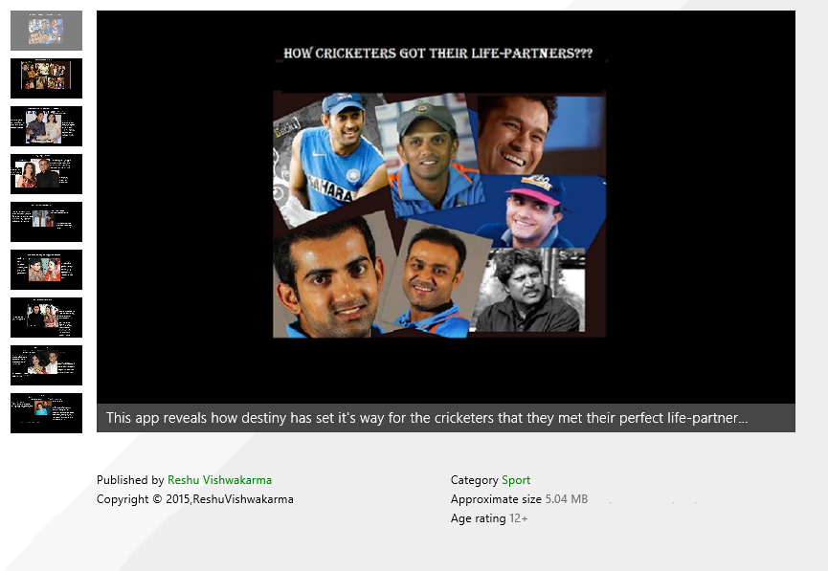

**Abhishek Hingnikar [CS batch 2015 ] ,Deepali Kushwaha[CS 7th sem],Purvi Jain[IT 7th sem], Joseph Landes[**[**General Manager of Developer Evangelism**](https://www.facebook.com/pages/General-Manager-of-Developer-Evangelism/216460508546851?ref=br_rs)**at**[**Microsoft**](https://www.facebook.com/Microsoft?ref=br_rs)**INDIA].**

